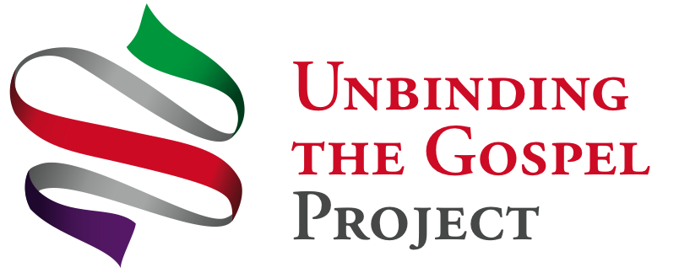
www.GraceNet.Info

TYPICAL LAY AND CLERGY EVALUATION
Compilation of 44 lay and clergy responses 3 months into coaching process

- What’s the most important thing you’ve learned so far?

Main themes: a. Process is doable/possible! We can DO it – daily prayer, share without fear
Example of faith overflowing rather than dumping on people
b. Prayer – persistence in prayer/power of prayer/trusting in God/listening to God
c. Completing the process will make a huge difference in us personally, the congregational relationships and our ministry outside the church
d. Be creative about setting up small groups and about the process
d. Many variations on ‘It’s all about sharing our stories’ – God’s story and our stories
e. It’s all about community, community, community
f. It’s about faith, prayer & sharing – not ‘evangelism’ – ‘think of E-vent as a ‘spiritual campaign’
g. That my lay leaders are starting to believe and take ownership of the process
h. People’s energy/enthusiasm (contagious: ‘it’s been a hard sell for me’)
i. We don’t need to have all the answers/there’s no failure, only success

- What are you going to keep thinking about?

Main themes: a. How to get E-vent started/creative way to introduce UTG to congregation/how to initiate the small group process successfully
b. How to work w/inevitable resistance/how to convince others to do it/ how to reach goal of 85%
c. Prayer – being open to the Spirit’s guidance and to change
d. Trusting God to lead – listening to God
e. How to get people excited about praying and sharing their faith/how to spread the joy to others
f. How to start a conversation w/non-Christians
g. Sermon prep (2)

Typical Lay & Clergy Evaluation
Page 1 of 2

- What specific steps are you going to take next?

Main themes: a. Planning: meet w/lay leaders to help them organize/get lots of input/set meeting dates
b. Preparation: identify key people to success/build/organize the teams/set target dates
c. Start weekly meetings/check in w/leaders about groups
d. Pray/talk-talk-talk/let Spirit guide/write about experience
e. Re-distribute my time to do a better job/study Church/begin studying & doing exercises in Heart to prepare to lead/re-focus on prayer and prayer journal

- What did you love most about the Prayer and Workshop Day with other churches?

Main themes: a. Sharing faith stories/ideas/experiences/sharing stories about God’s presence
b. Camaraderie/fellowship w/other churches/community/meeting new people
c. Joy and prayers/praying/the intercession/the prayer cards/praying about prayer requests
d. How much enthusiasm is there!/sharing in the energy present today (the Spirit)/seeing the excitement about beginning the journey/see committed inspired people
e. The exercises and sharing w/one or two others/the last exercise
f. Anticipating the future growth of the church through UTG
g. Learning!
h. Everything!

Typical Lay and Clergy Evaluation
Page 2 of 2

